Schedule Optimizer
User Interface Design

Submitted to:

Prof. Ma. Rowena C. Solamo
Faculty Member
Department of Computer Science
College of Engineering
University of the Philippines, Diliman

Submitted by:
Cavan, Antonio D.
Ramos, John Matthew G.
See, Engelberg Jeremy T.

In partial fulfillment of Academic Requirements
for the course
CS 191 Software Engineering I
of the
1st Semester, AY 2019-2020

Unique Reference:
The documents are stored in the https://github.com/DarkLuminosity/Schedule-Optimizer/tree/master/03-Design%20Engineering.

Document Purpose:
The purpose of the document is to showcase how the different scenarios would look like when the app will be developed. It would also contain the prototype which would be the basis of the design of the application going forward. The document will also inform the target audience the different features that can be improved to make it intuitive and aesthetically appealing to probable users. By having a prototype, it would also inform the developers on how the users would be interacting with the application.

Target Audience:
The target audience would be UP Diliman undergraduate students.

Revision Control:
Revision Date | Person Responsible | Version  Number | Contribution/Modification
10/09/19 | Engelberg See | 1.0 | Initial Document
10/18/19 | John Matthew Ramos | 2.0 | Filled in Schedule of the participatory design table, Participatory design notes, and Observation Summary and Prioritization
10/18/19 | Engelberg See | 3.0 | Added Initial Prototype link, Participatory Design Protocol and edited Prioritization in Observation Summary and Prioritization
10/18/19 | Antonio Cavan | 4.0 | Added Sample Screens of Revised Prototype and Revised Prototype Link

Table of Contents
I . Participatory Design Guide and Protocol 4
A . Purpose 4
B . Target participants 4
C . Participant’s Consent 4
D . Initial Prototype Link 4
E .Data Collection 4
F . Schedule of the Participatory Design 4
G . Participatory Design Protocol 5
II . Participatory Design Notes 6
III . Participatory Design Report 7
A . Observation Summary and Prioritization 7
B . Sample Screens of the Revised Prototype 7
C . InVision Link(s): 7

I. Participatory Design Guide and Protocol

This section provides the instructions on how to conduct a participatory design to assess the usability of the prototypes.

A. Purpose
The purpose of the participatory design is to gather information on how users will interact with the application. It is also done to assess the usability of the application.

B. Target participants

The target participants would be UP Diliman undergraduate students.

C. Participant’s Consent

Participants will sign a consent form to participate in this activity. One copy of the informed consent should be given to the participants, and a second copy should be kept by the team. Participants should be informed that a video recording will be used as data collection.

The participation in this study is completely voluntary, and the participants may refuse to participate or withdraw from the study without penalty or loss of benefits of the group. They may withdraw by informing the team that they no longer wish to participate (no questions will be asked).

D. Initial Prototype Link
The prototype would contain multiple different scenarios. It shows how the user could indicate the subjects he or she would be taking by adding, editing and removing them. It also shows how the user could indicate the preferences he or she would need to pick to indicate which preference would be prioritized in the making of their optimized schedule. Lastly, it would also show how the user could view the different optimized schedules as well as the result that would manifest when they choose to save the said schedule.
Prototype Link: https://github.com/DarkLuminosity/Schedule-Optimizer/blob/master/03-Design%20Engineering/Schedule-Optimizer%20Initial%20Prototype.studio

E. Data Collection

The participatory design are recorded if agreed by participants, and transcribed verbatim for analysis. The recordings need to be securely stored. The transcription shall not contain information that would allow individuals to be linked to specific statements. Confidentiality will be strictly preserved. Another member of the team may take down notes. The notes will be analyzed later.

F. Schedule of the Participatory Design

The participatory design can last about 7 minutes.
Participant | Date and Time | Venue
Vincent Delos Santos | October 17 - 3:47 PM | Melchor Hall
Zaira Dela Calzada | October 17 - 3:56 PM | Melchor Hall
Cid Azcarraga | October 17 - 4:33 PM | Alumni Engineers Centennial Hall

G. Participatory Design Protocol
Welcome and thank you for volunteering to take part in this participatory design. You have been asked to participate as your point of view is important. I realize you are busy and I appreciate your time.
Introduction: This participatory design is being done to help us understand how you will be interacting with our prototype. Please, feel free to state what you feel and think about the prototype of our product.
Anonymity: Despite being videotaped, I would like to assure you that the discussion will be anonymous. The transcribed notes of the participatory design will contain no information that would allow individual subjects to be linked to specific statements. You should try to answer and comment as accurately and truthfully as possible.
The project application would be a schedule optimizer. Included in the optimizer are the abilities to choose which subject to include in an optimized schedule depending on the rank of preferences that the user will choose. The final result or objective of the application is to show different optimized schedules based on these preferences and allowing the user to save which schedule he or she is satisfied with.

The user would need to indicate his or her desired subject by searching it from the list of subjects presented. Afterwards, he or she has a choice to remove a subject by clicking on it as well as editing their hierarchy of prioritization. He or she could then finalize the chosen list of subjects to get to indicate the preferences he or she wants. By ranking them either as 1, 2 or 3, the next step would be viewing the different optimized schedules presented within the application. Included is an option of saving the said schedule to the gallery of their phone by clicking the download button.

Conclusion: Of all the things that you mentioned today, what would you say are the most important thing that we (developers) need to keep in mind.

- Thank you for participating. This has been a very successful discussion.
- Your opinions will be a valuable asset to the study.
- We hope you have found the discussion interesting
- If there is anything you are unhappy with or wish to complain about, please contact the local PI or speak to me later

II. Participatory Design Notes

Video Transcript:

Participant 1:

- Maganda yung home page. Gives a good app vibe. No comment in the desired subjects page. Adjust the preference for each subject. Also he would prefer lighter colors or earth colors, not the current color scheme. He also likes the loading screen. Giving out the schedules and it’s the student’s job to enlist them. More functionalities like, in the case of conflict subjects with good professors, the app will show the reviews or rank of both subjects. Likes the schedule saving functionality.
- *Remark: The subjects are ranked.

Participant 2:

- The schedule UI is cute. No comments. Why is the app orange? Asterisks are confusing.

Participant 3:

- Doesn’t know where to press. The plus is very intuitive. A better UI would have bigger subjects. Better UI would be a minus sa side because pressing it doesn’t usually mean delete. The text needs to have better contrast sa background so the text should be lighter. He likes the schedule. Doesn’t show the demand. Liked the fact na pwede idownload. Would want a button to delete or edit. He liked the app and he thinks its useful. Its very straightforward pero may few screens that you don’t know what to do.

III. Participatory Design Report

A. Observation Summary and Prioritization

Observation | Prioritization  (using MoSCoW)
Different color scheme | Should have
Edit button at the desired subjects page | Must have
Minus button next to subject to delete subject | Should have
Bigger Subjects in the subjects list page | Should have
Instructions like tap to continue in home page | Should have

B. Sample Screens of the Revised Prototype

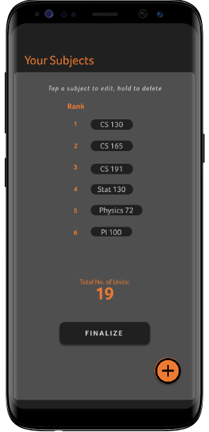

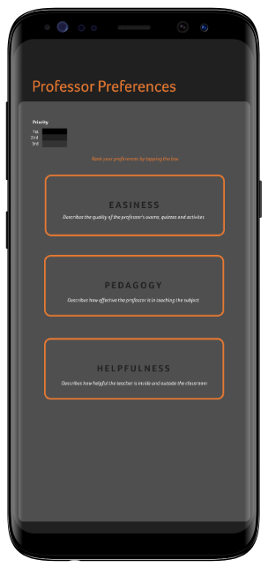
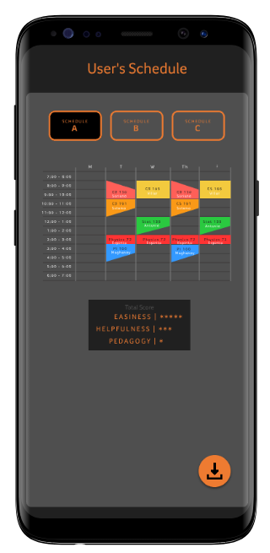

C. InVision Link(s):

https://drive.google.com/drive/u/1/folders/16iPz_il6GTJ6BrmIQF9bpXUiJsMlQK6V

